
NELLAI NADAR COLLEGE OF ENGINEERING
AND TECHNOLOGY

Approved AICTE| Affiliated to Anna University
Nedungundram, Chennai-127



DEPARTMENT OF
ARTIFICIAL INTELLIGENCE & DATA SCIENCE

Project name

RePlastix Innovations: Transforming Plastic Waste into Sustainable Solutions

Team Members

MALARVIZHI V (Team leader)
DHINA R (Member)
BERNART ANDREW B(Member)
VISHAL.E(Member)
MADHESH S S(Member)

RePlastix Innovations: Transforming Plastic Waste into Sustainable Solutions

User Story:
As an Operations Manager at RePlastix Innovations, I want to manage plastic waste recycling operations, inventory levels, order processing, replenishment requests, approvals, and reporting through a centralized Salesforce application so that I can reduce manual work, improve operational efficiency, ensure timely stock availability, maintain secure and structured data access, and support sustainable business processes through automation and real-time decision-making.

INTRODUCTION

Project Overview
Plastic waste management has emerged as a critical industrial and environmental challenge in modern society. As businesses and municipalities strive to reduce landfill dependency and promote sustainable practices, there is a growing need for digital platforms that can manage the end-to-end lifecycle of recyclable plastic
materials. These platforms must support collection tracking, inventory visibility, order management, communication workflows, and operational reporting.
The project titled “RePlastix Innovations: Transforming Plastic Waste into Sustainable Solutions” is designed as a Salesforce-based CRM application that addresses these requirements through process automation and centralized data management. The solution enables RePlastix Innovations to digitize and streamline core operations related to plastic waste recycling and sustainable material processing.

Purpose
The purpose of this project is to build a smart and scalable Salesforce solution that supports the daily operational and reporting needs of a plastic recycling
organization.

The major purposes of this project are:
- To automate inventory monitoring and replenishment workflows
- To streamline order and task management processes
- To improve operational visibility across departments
- To implement secure and role-based access to business data
- To reduce manual errors and improve data accuracy
- To generate reports and dashboards for performance tracking
- To support sustainability-driven business operations

Scope
The scope of the project includes the design and implementation of a Salesforce- based application tailored for RePlastix Innovations. The application focuses on business process automation rather than physical recycling machinery or IoT integration.

Scope includes:
- Custom object creation for operational data
- User roles and profiles
- Inventory tracking workflows
- Automated low-stock task generation
- Order update mechanisms
- Replenishment request processing

- Approval notification workflows
- Reports and dashboard analytics

Scope excludes:
- Physical recycling machine control
- Live sensor or hardware integration
- Financial accounting ERP integration
- Mobile app development (future scope)

Objectives
Primary Objectives:
- To develop a centralized CRM platform for recycling operations
- To automate repetitive tasks and inventory-based alerts
- To ensure secure data access and structured record management
- To improve reporting accuracy and management visibility

Secondary Objectives:
- To enhance cross-functional coordination
- To support warehouse and procurement responsiveness
- To maintain better stock availability
- To promote sustainability through operational intelligence

IDEATION PHASE
  - Problem Statement (Customer Problem Statement Template)

The ideation phase identifies the pain points experienced by the users involved in the recycling and inventory lifecycle at RePlastix Innovations.

PS  No | Customer | I’m trying to | But | Because | Which makes me feel
PS-1 | Inventory Manager | Maintain sufficient recycled  material stock | Stock levels are not monitored consistently | Manual checking is time-  consuming and error-prone | Pressured and reactive
PS-2 | Operations Manager | Coordinate recycling and order workflows | Reports are delayed and incomplete | Processes are disconnected and dependent on manual  communication | Frustrated and  inefficien
PS-3 | Warehouse Manager | Restock  materials on time | Departments are not updated in  real time | There is no automated  notification system | Unprepared and delayed
PS-4 | Management Team | Track  performance and  sustainability metrics | Reports are difficult to consolidate | Data is scattered  across systems | Uncertain and disconnected

Empathy Map Canvas Target Users
- Inventory Manager
- Warehouse Manager
- Operations Manager

- Procurement Team
- System Administrator
- Business Analysts
- Senior Management

Empathy Analysis

Aspect | Description
Think & Feel | Need reliable stock information and operational visibility
Hear | Pressure from management regarding delivery and sustainability goals
See | Fragmented records, delayed updates, inconsistent reporting
Say & Do | Follow up manually, update spreadsheets, assign tasks reactively
Pain | Stockouts, delays, poor coordination, data inconsistency
Gain | Automation, visibility, faster action, better control

Brainstorming
During the brainstorming phase, several solution approaches were evaluated to identify the most suitable digital platform for managing plastic recycling
operations.

Brainstormed Ideas
- Spreadsheet-based stock and order management

- Desktop inventory software
- Web-based custom recycling portal
- ERP-based waste management solution
- Salesforce-based CRM and automation platform

Selected Idea:
Salesforce-Based Sustainable Operations Management System for RePlastix Innovations
Reason for Selection
The Salesforce platform was selected because it provides:
- Secure cloud infrastructure
- Scalable data modeling
- Workflow automation
- Approval and notification features
- Role-based access control
- Powerful reporting and dashboards
- Low-code / no-code development support

Value Proposition
The proposed system provides value by connecting inventory, operations, order processing, and reporting into a single digital workflow.

Key Value Delivered
- Reduced operational delays
- Better stock availability
- Faster response to low inventory situations

- Improved interdepartmental communication
- Better compliance and audit traceability
- Sustainability-focused reporting

REQUIREMENT ANALYSIS PHASE:
  - Customer Journey Map
The following journey map illustrates how users interact with the Salesforce system to manage inventory and recycling workflows.

Journey Stages
- User Login
- Access RePlastix Lightning Application
- View Product / Inventory Records
- Monitor Stock Levels
- Detect Low Inventory
- Create / Update Replenishment Requests
- Approve Requests
- Notify Warehouse Manager
- Update Inventory and Orders
- Generate Reports and Dashboards
- Analyze Sustainability KPIs

Solution Requirements:

Functional Requirements

FR No | Requirement
FR-1 | Secure user login and authentication
FR-2 | Role and profile-based data access
FR-3 | Inventory object creation and stock management
FR-4 | Automated task creation for low stock
FR-5 | Order status update automation
FR-6 | Replenishment request generation
FR-7 | Approval workflow implementation
FR-8 | Email notification to warehouse manager
FR-9 | Reporting and dashboard generation
FR-10 | Sustainability KPI monitoring

Non-Functional Requirements NFR-1: Usability
The system should be easy to use for operational staff and administrators.

Requirements:
- Simple Lightning UI
- Clear navigation
- Minimal manual data entry
- Role-specific views

Example:
An inventory manager should be able to identify low stock products and view associated replenishment tasks without requiring technical assistance.

NFR-2: Security

The system must protect business-sensitive and operational data.

Requirements:
- Roles and profiles
- Object-level security
- Field-level security
- Secure login and password policies

Example:
Warehouse staff should access only stock and replenishment-related records, while senior management can access performance dashboards.

NFR-3: Reliability
The application should store operational records accurately and remain consistently available.

Requirements:
- Automatic record saving
- Stable cloud environment
- Error handling in automation
- Record traceability

Example:
When a low stock event occurs, the associated task and replenishment request should be created without failure.

NFR-4: Performance
The system should process workflows and reports efficiently.

Requirements:

- Fast page loading
- Timely flow execution
- Quick report generation
- Smooth dashboard rendering

Example:
Low stock-triggered task creation should happen almost immediately after stock thresholds are crossed.

NFR-5: Availability
The application should be accessible when needed by all operational teams.

Requirements:
- Cloud availability
- Minimal downtime
- Cross-device accessibility
- Business continuity

Example:
Managers should be able to review stock and replenishment activity during business hours without interruptions.

NFR-6: Scalability
The solution should support growth in products, orders, and departments.

Requirements:
- Support more records
- Expandable object design
- Higher workflow volume
- Future integration capability

Example:
As RePlastix expands to multiple facilities, the system should still support larger inventory and order volumes without redesign.

Data Flow Diagram:

Textual Data Flow
User → Salesforce Lightning App → Custom Objects → Validation Rules → Flows / Approval Processes → Task / Order / Replenishment Records → Email Notifications → Reports → Dashboards

Major Data Flow Components
- Inventory Data Input
- Product Stock Monitoring
- Order Update Process
- Task Generation Process
- Replenishment Approval Flow
- Warehouse Notification
- Reporting and KPI Output

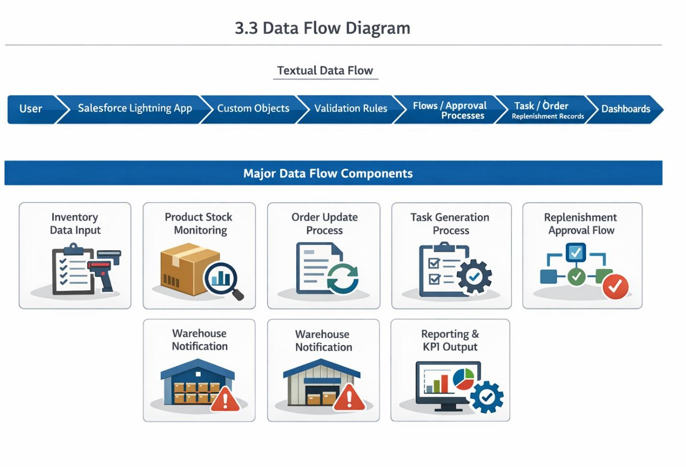

Technology Stack:

Layer | Technology
Frontend | Salesforce Lightning Experience
Backend | Salesforce Platform
Database | Salesforce Cloud Database
Automation | Salesforce Flows
Security | Roles, Profiles, Permissions
Analytics | Reports & Dashboards
Notifications | Email Alerts
Business Logic | Validation Rules, Formula Fields, Approvals

  - Feasibility Study:

Technical Feasibility
The Salesforce platform provides all required features such as custom objects, automation, approval flows, and dashboards.

Operational Feasibility

The application aligns with the existing workflow needs of RePlastix Innovations and can be adopted by operations teams with minimal training.

Economic Feasibility
The solution reduces manual effort, operational delays, and stock-related inefficiencies, making it cost-effective in the long run.

Schedule Feasibility
The project can be developed in planned milestones using agile sprint-based execution.

PROJECT DESIGN PHASE:

Problem–Solution Fit
RePlastix Innovations faces challenges related to fragmented inventory tracking, delayed replenishment, and limited operational visibility. The proposed Salesforce CRM solution addresses these issues by digitizing operational records and
automating critical business workflows.

Problem–Solution Mapping

Problem | Proposed Solution
Low stock not noticed in time | Automated threshold-based stock monitoring
Delayed replenishment | Auto-generated request process
Manual coordination between departments | Task and email automation

Problem | Proposed Solution
Lack of operational reporting | Real-time reports and dashboards
Unstructured access to data | Roles and profiles

Proposed Solution
The proposed solution is a cloud-based Salesforce application that supports recycling operations through structured data management and workflow automation.

Core Functional Components:

Parameter | Description
User Login & Authentication | Secure login for authorized users
Role-Based Access | Customized access based on user responsibility
Inventory Management | Track stock levels and product records
Order Management | Manage order records and stock impact
Low Stock Automation | Create tasks when stock threshold is breached

Parameter | Description
Replenishment Request | Initiate low-stock restocking workflow
Approval Workflow | Approve replenishment requests
Email Notification | Notify warehouse manager after approval
Reports | Generate operational and stock reports
Dashboards | Visualize KPIs and sustainability metrics

  - Solution Architecture:

Architecture Layers
- Presentation Layer – Salesforce Lightning UI
- Application Layer – Flows, Approval Processes, Validation Rules
- Data Layer – Custom Objects and Relationships
- Security Layer – Roles, Profiles, Permission Controls
- Analytics Layer – Reports and Dashboards
This layered architecture ensures maintainability, security, and scalability.

Data Model Design Proposed Custom Objects
- Product / Inventory
- Order
- Replenishment Request

- Warehouse Task
- Sustainability Report
- Supplier (optional expansion)

Relationships
- One Product can have many Orders
- One Product can trigger many Tasks
- One Product can have multiple Replenishment Requests
- One Manager can own multiple stock-related tasks

Important Fields
- Product Name
- Stock Quantity
- Threshold Limit
- Stock Status
- Replenishment Status
- Order Status
- Approval Status
- Assigned Owner
- Sustainability Metric Fields

Security Architecture:
RePlastix Innovations has implemented a robust security architecture to ensure controlled access and operational integrity.

Security Features

- User Roles
- Profiles
- Object-Level Security
- Field-Level Security
- Record Ownership
- Approval Visibility Control

Example Role Segregation
- System Administrator – Full access
- Inventory Manager – Product and stock access
- Warehouse Manager – Restock and task access
- Operations Manager – Order and replenishment visibility
- Business Analyst – Report and dashboard access
This approach ensures that users can access only the information relevant to their responsibilities, thereby enhancing both security and usability.

PROJECT PLANNING & SCHEDULING:

Project Planning
The project followed an Agile-based development methodology with defined milestones and sprint execution.

Project Planning Activities
- Salesforce Developer Org setup
- Requirement gathering and business process understanding
- Custom object design

- Roles and profiles creation
- Inventory workflow design
- Automation flow development
- Approval and email notification configuration
- Report and dashboard creation
- Testing and validation
- Final deployment documentation

  - Product Backlog, Sprint Schedule, and Estimation:

Sprint | Functional Requirement (Epic) | User  Story No | User Story / Task | Story  Points | Priority | TeamMembers
Sprint-1 | Developer Setup | USN-1 | As an admin, I want to create a Salesforce developer account so that I can configure the RePlastix system. | 1 | High | MALARVIZHI V
Sprint-1 | Security Setup | USN-2 | As an admin, I want to create roles and profiles so that data access is secure and role-based. | 3 | High | DHINA R
Sprint-2 | Data Modeling | USN-3 | As an admin, I want to create Product, Order, and Replenishment objects so that operational data can be managed centrally. | 5 | High | BERNART ANDREW B
Sprint-2 | Lightning App | USN-4 | As a user, I want a dedicated Lightning App so that I can access all modules from one place. | 3 | High | VISHAL.E
Sprint-2 | Data Fields | USN-5 | As an admin, I want to create fields and relationships so that stock and order details can be captured accurately. | 5 | High | Madhesh S S
Sprint-3 | Automation | USN-6 | As a system, I want to create tasks automatically when stock falls below threshold. | 5 | High | MALARVIZHI V
Sprint-3 | Automation | USN-7 | As a system, I want to update order status when stock is low so that operations reflect current availability. | 4 | High | DHINA R
Sprint-4 | Workflow | USN-8 | As a system, I want to generate replenishment requests so that procurement can act immediately. | 5 | High | BERNART ANDREW B
Sprint-4 | Approval | USN-9 | As a manager, I want replenishment requests to go through approval before restocking. | 4 | Medium | VISHAL.E
Sprint-5 | Notifications | USN-10 | As a system, I want to send email notifications to the warehouse manager after approval. | 4 | High | Madhesh S S
Sprint-6 | Analytics | USN-11 | As a business analyst, I want reports and dashboards so that I can monitor operational performance. | 5 | High | MALARVIZHI V
Sprint-6 | Sustainability | USN-12 | As a manager, I want sustainability reports so that I can track environmental impact and progress. | 4 | Medium | VISHAL.E

  - Project Tracker, Velocity & Burndown Chart:

Sprint | Total Story Points | Duration | Sprint Start Date | Sprint End Date (Planned) | Story Points Completed | Sprint Release Date (Actual)
Sprint- 1 | 10 | 5 Days | 01 Jan 2026 | 05 Jan 2026 | 10 | 05 Jan 2026
Sprint- 2 | 13 | 6 Days | 06 Jan 2026 | 11 Jan 2026 | 13 | 11 Jan 2026

Sprint | Total Story Points | Duration | Sprint Start Date | Sprint End Date (Planned) | Story Points Completed | Sprint Release Date (Actual)
Sprint- 3 | 9 | 5 Days | 12 Jan 2026 | 16 Jan 2026 | 9 | 16 Jan 2026
Sprint- 4 | 9 | 5 Days | 17 Jan 2026 | 21 Jan 2026 | 9 | 21 Jan 2026
Sprint- 5 | 4 | 3 Days | 22 Jan 2026 | 24 Jan 2026 | 4 | 24 Jan 2026
Sprint- 6 | 9 | 5 Days | 25 Jan 2026 | 29 Jan 2026 | 9 | 29 Jan 2026

Velocity Observation
The project maintained a steady sprint velocity and completed all planned story points within the estimated duration.

Burndown Summary
The burndown trend indicates a smooth completion of sprint goals, with minor dependencies handled during sprint reviews.

  - Risk Management:

Risk | Impact | Mitigation
Incorrect automation logic | High | Unit testing and flow validation
Access misconfiguration | High | Role/profile review
Delayed approvals | Medium | Automated notifications
Data inconsistency | Medium | Validation rules
Scope creep | Medium | Sprint backlog control

Deliverables:

Final Deliverables
- Salesforce CRM Application
- Custom Objects and Data Model
- Roles and Profiles Configuration
- Inventory Automation Workflows
- Approval and Notification Process
- Reports and Dashboards
- Final Project Documentation

PROJECT DEVELOPMENT PHASE:
  - Introduction to Development Phase
The development phase of the project focused on implementing the business requirements of RePlastix Innovations within the Salesforce platform. This phase

involved configuring the Salesforce environment, creating a secure user access structure, designing custom objects, defining field relationships, building automation workflows, and developing reporting capabilities.
The application was designed to support the operational needs of plastic waste recycling management, inventory control, order tracking, replenishment approvals, and sustainability reporting. The development approach emphasized scalability, automation, data security, and usability so that the system could effectively support both daily operations and management-level decision-making.
The following components were developed as part of the Salesforce implementation:
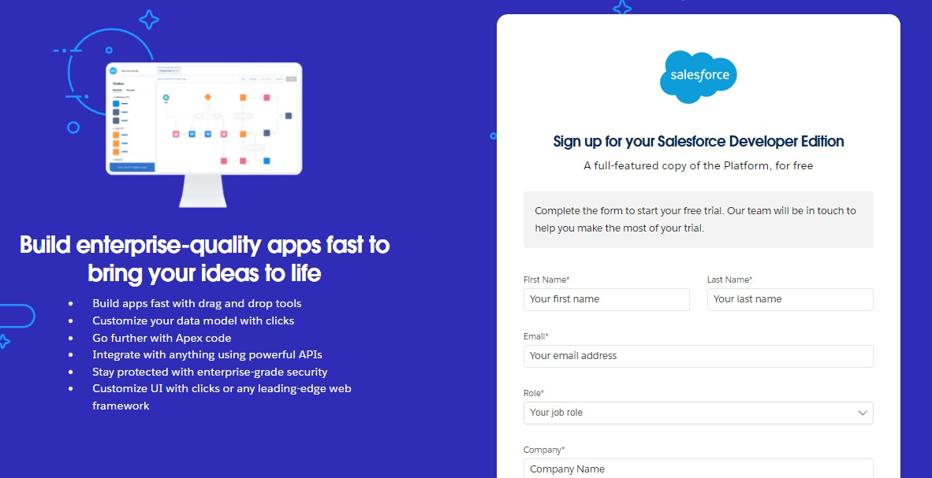
- Creating a developer org in salesforce
Go to https://developer.salesforce.com/signup On the sign up form, enter the following details
- First name & Last name
- Email
- Role : Developer
- Company : College Name
- County : India
- Postal Code : pin code
- Username : should be a combination of your name and companyThis need not be an actual email id, you can give anything in the format : username@organization.com

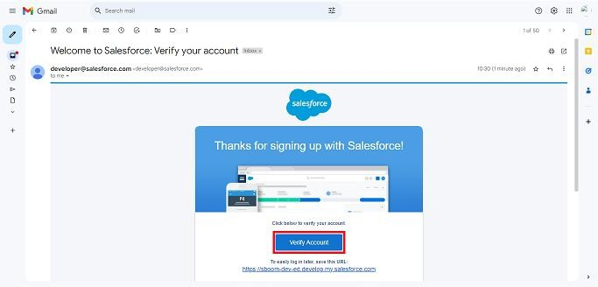
Account Activation

- Go to the inbox of the email that you used while signing up. Click on the verify account to activate your account. The email may take 5-10mins.
- Click on Verify Account
- Give a password and answer a security question and click on change password.
  - Salesforce create Objects

    - Re Plastic Innovations Plastic Waste
    - Re Plastic Innovations Recycling Center
    - Re Plastic Innovations Recycled Product
    - Re Plastic Innovations Order
    - Re Plastic Innovations Restock Request

  - Role and Profile Configuration
- From the setup menu, search and select roles.
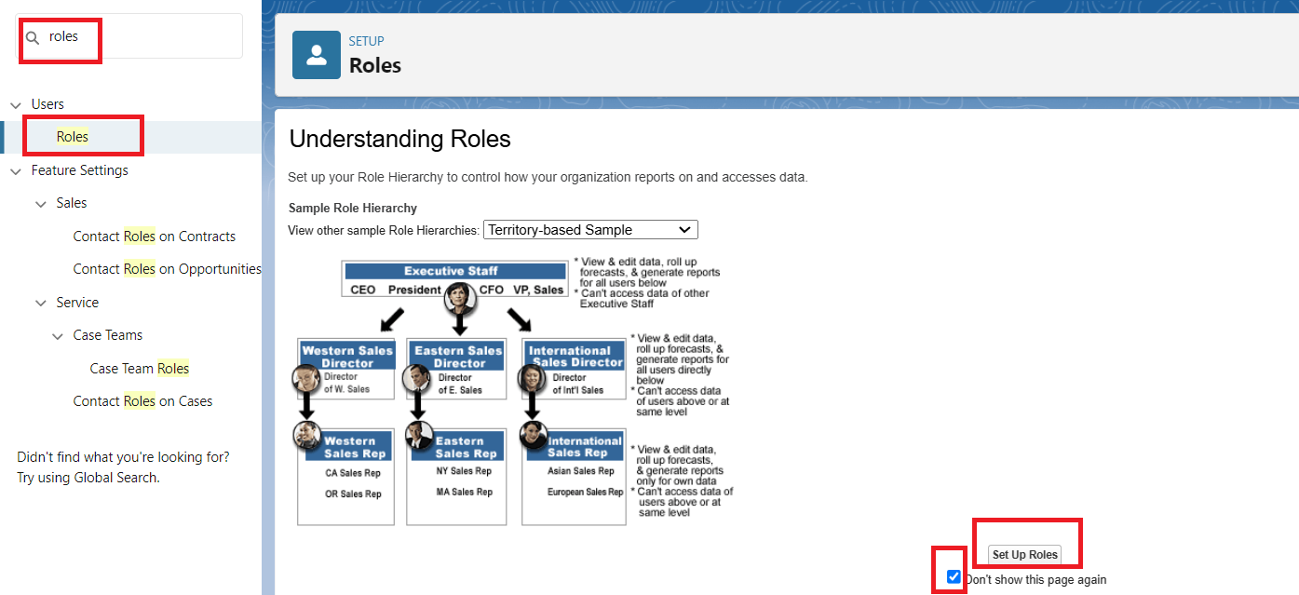

- Click Add Roles CEO Below Option.
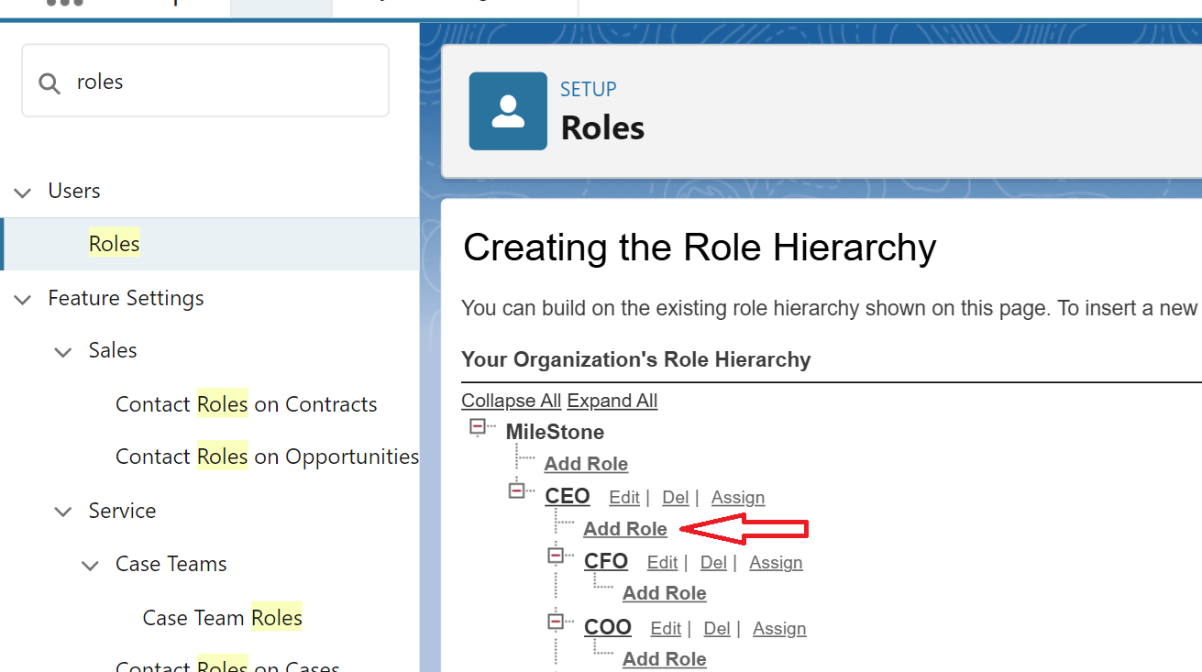

- Label : Recycling Manager
- This Role Reports To : CEO
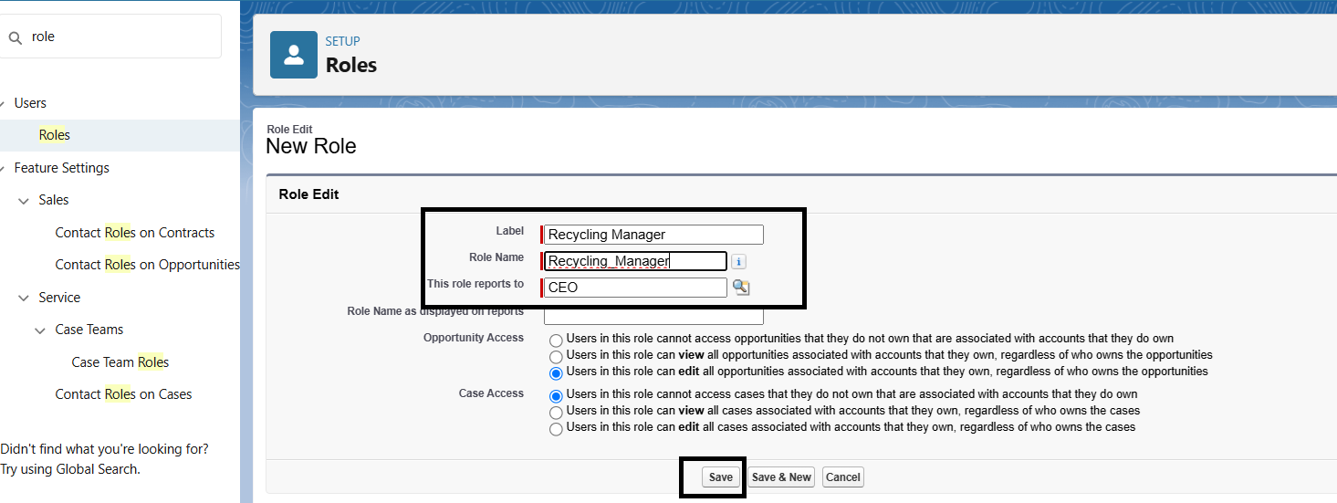
- Click Save and New
  - Custom App Creation
    - Go to setup page → search “app manager” in quick find → select “app manager”
→ click on New lightning App.
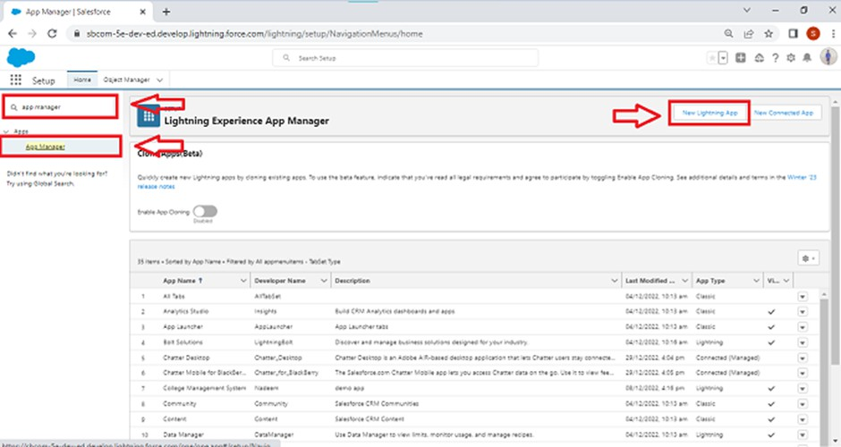

    - Fill the app name in app details and branding as follow
    - App Name : Re Plastic Innovations
    - Developer Name : this will auto populated
    - Description : Give a meaningful description

    - Image : optional (if you want to give any image you can otherwise not mandatory)
    - Primary color hex value : keep this default
    - Then click Next → (App option page) keep it as default → Next → (Utility Items) keep it as default → Next.
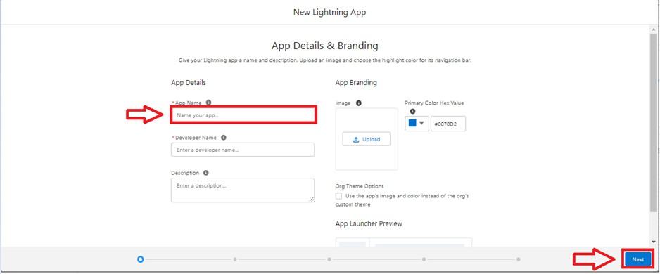
      - To Add Navigation Items
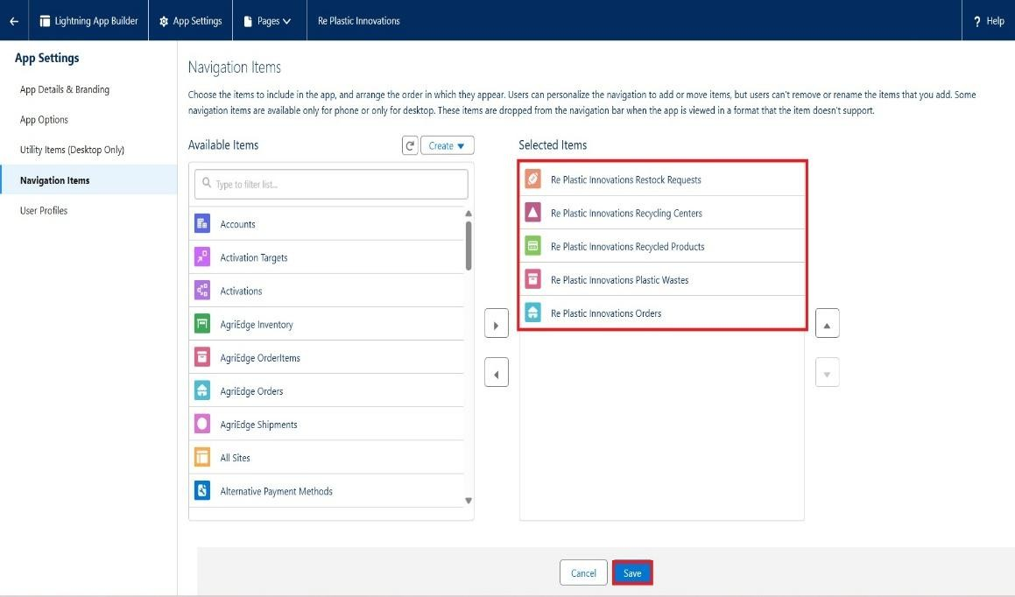
      - Search the items in the search bar(Restock Requests, Recycling Centers, Recycled Products, Plastic Wastes, Orders) from the search bar and move it using the arrow button → Next.
  - Fields and Relationships
    - Select DataType as Lookup Relationship.

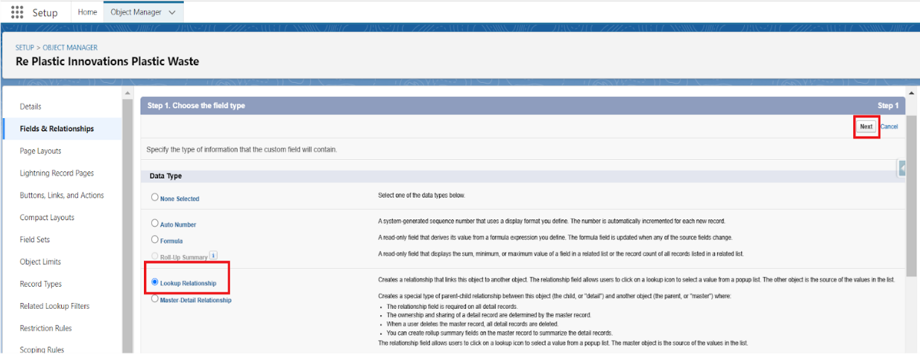

- Click Next
- Select Re Plastic Innovations Recycling Center Object Form Related Filed.
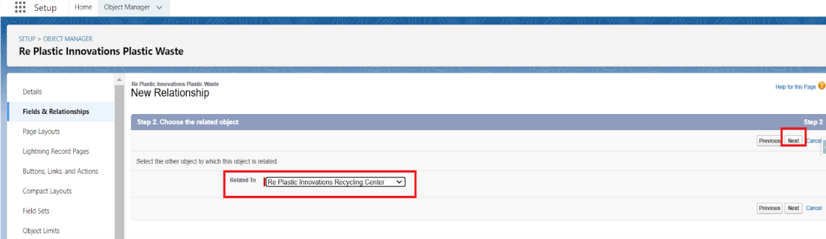
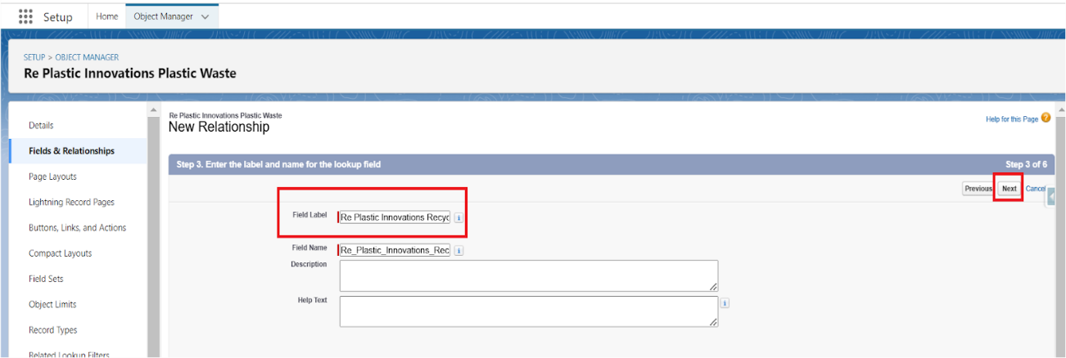

- Label Name Re Plastic Innovations Recycling Center and Click Next

- Click Next and Save.
  - Page Layouts
  - Validation Rules
  - Formula Fields
  - Flows and Automation
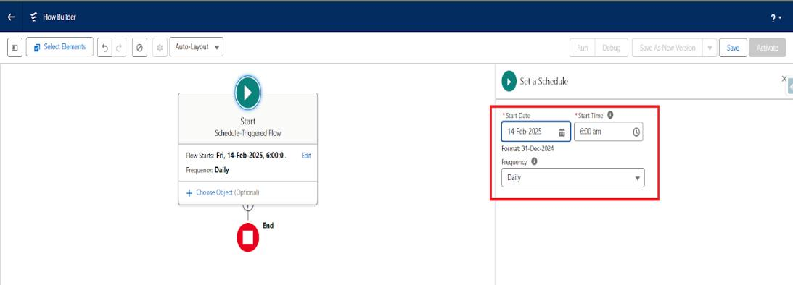
- Label : Recycling Manager
- This Role Reports To : CEO
- Click Save and New
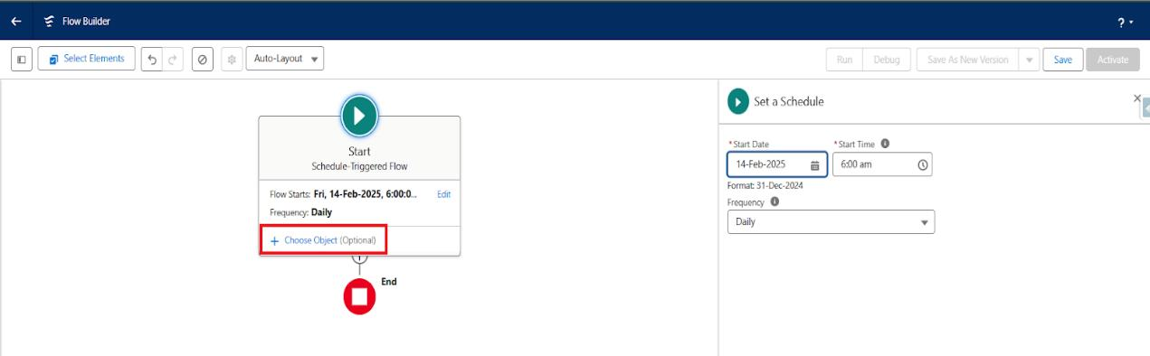
- Select Re_Plastic_Innovations_Recycled_Product c Object
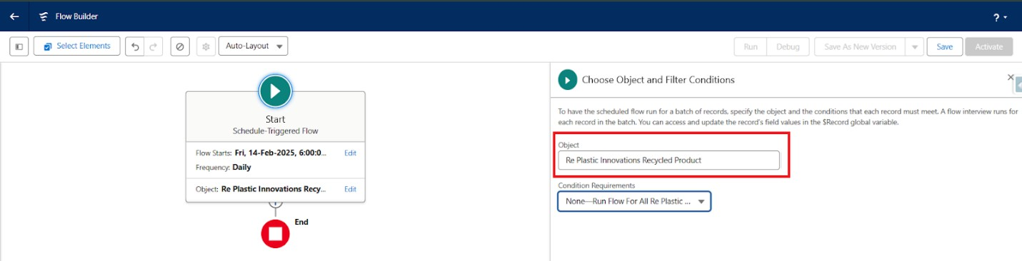

- Click Plus Icon For Add Decision Element

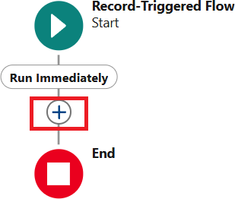
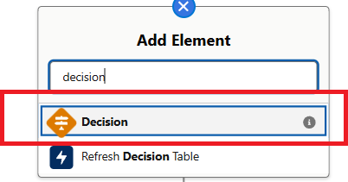

  - Label Name : Decision 1
  - Out Come Details : Outcome 1 of Decision 1
  - Conditions : {!$Record.Stock_Level c} LessThan {!$Record.Threshold c}
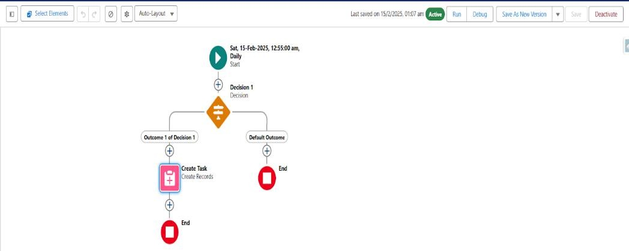

  - Label : Create Task
  - How to Set Field Values : Manually
  - Create a Record Of the Object : Task
  - Set Filed Values for the task:
  - Assigned To ID : {!$Record.OwnerId}
  - Related To Id : {!$Record.Id}
  - Priority : High
  - Subject : Please Look in this Stock Is Low Fill The Stock ASAP
  - Status : In Progress

  - Approval Process
  - Email Notification
  - Reports and Dashboards

Salesforce Org Setup
The first step in the implementation process was to configure the Salesforce environment required for the development of the RePlastix Innovations
application. A dedicated Salesforce Developer Org was used to create and test the complete CRM-based solution.

Activities Performed
- Salesforce Developer Account creation
- Login and environment access setup
- Lightning Experience activation
- User settings configuration
- App launcher and navigation setup

- Organization customization
The use of Salesforce Lightning Experience provided a modern and intuitive interface that allowed faster development and easier end-user interaction.

Roles and Profiles Configuration
Data security and access control were considered essential requirements in this project. RePlastix Innovations established a structured access framework using roles and profiles so that each user could access only the records and features relevant to their responsibilities.

Profiles Created
- System Administrator
- Inventory Manager
- Warehouse Manager
- Operations Manager
- Business Analyst

Roles Created
- CEO / Top Management
- Operations Head
- Inventory Supervisor
- Warehouse Team Lead
- Analyst Team Member

Purpose of Roles and Profiles
- To maintain data confidentiality
- To ensure record-level access control
- To provide a role-specific user experience

- To reduce the risk of unauthorized data modification
For example, the Inventory Manager was given access to stock records and replenishment-related objects, while the Business Analyst was provided access to reports and dashboards for performance monitoring.

Creation of Lightning Application
A dedicated Lightning Application was created for RePlastix Innovations to provide a centralized interface for all business modules.

App Name
RePlastix Innovations Management App Modules Included in the App
- Dashboard
- Product / Inventory
- Order
- Replenishment Request
- Tasks
- Reports
- Sustainability Metrics

Benefits of the Lightning App
- Single-point access to all modules
- Better navigation and usability
- Improved productivity for end users
- Enhanced visual consistency
The Lightning App acted as the central working environment for users across different departments.

Custom Objects Created
Custom objects were created to store and manage business data specific to
RePlastix Innovations. These objects formed the foundation of the application’s data model.
Custom Objects Used

S.No | Object Name | Purpose
1 | Product / Inventory | To store stock details of recycled plastic products
2 | Order | To manage customer or operational order records
3 | Replenishment Request | To initiate and track restocking requests
4 | Sustainability Report | To record environmental performance indicators
5 | Task | To assign low-stock follow-up actions

Object Description:

Product / Inventory Object
This object stores details related to available recycled plastic products and their stock levels.
Important Fields
      - Product Name
      - Product Code
      - Stock Quantity
      - Threshold Quantity
      - Stock Status
      - Unit Price

      - Product Category
      - Record Owner

Purpose
This object is central to inventory tracking. It is used to monitor product availability and trigger automated actions whenever stock falls below the defined threshold.

Order Object
The Order object captures order-related details for recycled products.

Important Fields
      - Order Name / Order ID
      - Product Lookup
      - Quantity Ordered
      - Order Date
      - Order Status
      - Unit Price
      - Total Amount
      - Customer Name

Purpose
This object helps track order activity and is updated automatically when inventory conditions affect product availability.

Replenishment Request Object
This object stores information about requests raised to restock products when stock is low.

Important Fields
      - Request ID
      - Product Lookup
      - Requested Quantity

      - Request Date
      - Approval Status
      - Request Owner
      - Warehouse Notification Status

Purpose
This object supports the restocking workflow and enables tracking of approval and warehouse action.

Sustainability Report Object
This object captures environmental and sustainability-related metrics.

Important Fields
      - Report Name
      - Reporting Month
      - Total Plastic Recycled
      - Carbon Savings Estimate
      - Waste Diverted from Landfill
      - Sustainability Remarks

Purpose
This object enables management to track environmental performance and sustainability goals.

Tabs Created:
To improve usability, tabs were created for the main custom objects.

Tabs Configured
- Product / Inventory Tab
- Order Tab
- Replenishment Request Tab
- Sustainability Report Tab
- Dashboard Tab
- Reports Tab

Purpose of Tabs
- Easy record access
- Faster navigation
- Improved user interaction
- Better app organization

Fields and Relationships
Proper field design and object relationships were implemented to ensure that operational data was stored accurately and linked meaningfully.

Relationship Types Used
- Lookup Relationship
- Master-Detail Relationship (where applicable)

Key Relationships
- Order → Product
- Replenishment Request → Product
- Task → Product (through workflow logic / record association)

Benefits
- Better data integrity
- Easier reporting
- Improved traceability of business operations

Page Layout Design
Customized page layouts were created for each object to improve usability and ensure that only relevant fields were visible to users.

Page Layout Features
- Organized field sections
- Required field visibility
- Related lists

- Role-specific usability
- Clean and structured record forms

Example
The Product page layout was designed to show:
- Stock Quantity
- Threshold Quantity
- Stock Status
- Related Orders
- Related Replenishment Requests
- Related Tasks
This layout helped users quickly understand product status and take action when necessary.

Validation Rules
Validation rules were created to ensure that users entered correct and meaningful data into the system.

Validation Rules Implemented

Stock Quantity Cannot Be Negative
Ensures that stock values are always zero or greater.

Threshold Quantity Must Be Positive
Ensures valid stock threshold values.

Order Quantity Cannot Be Blank
Ensures that every order has a valid quantity value.

Request Quantity Must Be Greater Than Zero

Prevents invalid replenishment requests.
- Approval Status Cannot Be Modified Improperly Ensures that request approval follows the intended workflow. Benefits of Validation Rules
  - Prevents incorrect data entry
  - Maintains record quality
  - Improves trust in reporting
  - Reduces downstream workflow errors

Formula Fields
Formula fields were used to automate calculations and reduce manual effort.

Formula Fields Implemented
- Total Amount

Formula:
Quantity Ordered × Unit Price

Stock Status
Automatically displays:
  - Low Stock
  - Available
  - Critical
based on current stock quantity and threshold value.
- Sustainability Efficiency Indicator Derived from available sustainability metrics. Benefits

  - Automatic calculations
  - Better decision support
  - Reduced manual errors
  - Improved data consistency

Workflow Logic and Automation
Automation was one of the most important parts of the project. RePlastix Innovations required the system to respond intelligently whenever stock levels became critically low.
This was implemented using Salesforce Flow Automation, which allowed the system to perform actions automatically without user intervention.

Inventory Automation Workflow

Low Stock Detection Process
A key automation requirement of RePlastix Innovations was to ensure that whenever the stock quantity of a product fell below a predefined threshold, immediate action was initiated.

Business Rule
If Product Stock Quantity < Threshold Quantity → Trigger automated action
Automation Outcome
When this condition is met, the system performs the following actions:
- Creates a new Task record
- Associates the task with the same product record
- Assigns the task to the record owner

- Flags the stock status as Low Stock
- Initiates replenishment-related workflow

Benefits
  - Prevents stockout delays
  - Eliminates dependency on manual stock checks
  - Improves operational responsiveness

Automatic Task Creation
When low stock is detected, a Task record is automatically created.

Task Details
      - Subject: Low Stock Alert
      - Related Record: Product
      - Assigned To: Product Record Owner
      - Status: Not Started
      - Priority: High

Purpose
The task serves as an operational reminder for the responsible user to take corrective action immediately.

Business Value
This ensures accountability and creates a structured action trail for inventory management.

Order Update Automation
The system was designed to ensure that product availability is reflected accurately in operational order records.

Workflow Logic
When stock is low:

      - The related Order object is updated automatically
      - The order reflects the current inventory condition
      - Status values can be updated to:
        - Pending Stock
        - Delayed
        - Awaiting Replenishment

Purpose
This keeps operational records synchronized with real-time stock conditions and avoids unrealistic order commitments.

Replenishment Request Generation
One of the most valuable features implemented in this project is the automatic replenishment request workflow.

Business Logic
If a product enters low-stock status:
      - A Replenishment Request record is generated automatically
      - The request includes:
        - Product Name
        - Current Stock
        - Threshold Quantity
        - Requested Restock Quantity
        - Request Date
        - Approval Status

Purpose
This removes the need for manual restock initiation and ensures that the replenishment cycle begins without delay.

Approval Process Implementation
To ensure proper business control and accountability, replenishment requests were not directly executed. Instead, they were routed through an approval process.

Approval Workflow
- Replenishment Request is created
- Request is submitted for approval
- Department Manager / Operations Head reviews the request
- Request is either:
  - Approved
  - Rejected

Approval Criteria
- Product necessity
- Stock urgency
- Requested quantity
- Operational need

Benefits
- Maintains governance
- Prevents unnecessary restocking
- Ensures formal authorization

Email Notification Workflow
After approval of the replenishment request, the system automatically sends an

email notification to the Warehouse Manager. Notification Purpose
The warehouse team must be informed immediately after approval so that they can proceed with restocking.

Email Includes
- Product details
- Approved request information
- Quantity to restock
- Reference to associated product record

Business Value

This automation improves communication between departments and reduces delays caused by manual follow-up.

Reports and Dashboards
Salesforce reporting capabilities were used to provide visibility into the operations of RePlastix Innovations.

Reports Created
- Product Inventory Report
- Low Stock Products Report
- Replenishment Request Report
- Order Status Report
- Sustainability Performance Report

Dashboards Created
- Inventory Health Dashboard
- Order Monitoring Dashboard
- Replenishment Activity Dashboard
- Sustainability KPI Dashboard

Dashboard Benefits
  - Quick decision-making
  - Visual KPI monitoring
  - Operational transparency
  - Better management oversight

6.16 Reports and Dashboards
Salesforce reporting capabilities were used to provide visibility into the operations of RePlastix Innovations.

Reports Created
- Product Inventory Report
- Low Stock Products Report

- Replenishment Request Report
- Order Status Report
- Sustainability Performance Report

Dashboards Created
- Inventory Health Dashboard
- Order Monitoring Dashboard
- Replenishment Activity Dashboard
- Sustainability KPI Dashboard

Dashboard Benefits
  - Quick decision-making
  - Visual KPI monitoring
  - Operational transparency
  - Better management oversight

FUNCTIONAL AND PERFORMANCE TESTING

Introduction to Testing
Testing was conducted to ensure that all modules and workflows in the RePlastix Innovations Salesforce application functioned correctly and met the defined requirements.
The testing phase focused on:
- Functional correctness
- Data validation
- Automation reliability
- Security behavior
- Workflow consistency

Test Cases

Test Case ID | Test Scenario | Expected Result | Status
TC-1 | Create Product Record | Product should be saved successfully | Pass
TC-2 | Enter negative stock quantity | Validation should prevent save | Pass
TC-3 | Reduce stock below threshold | Task should be created automatically | Pass
TC-4 | Low stock product update | Order status should update automatically | Pass
TC-5 | Generate replenishment request | Request should be created successfully | Pass
TC-6 | Submit request for approval | Request should enter approval workflow | Pass
TC-7 | Approve request | Warehouse email notification should be sent | Pass
TC-8 | Generate report | Report should display correct records | Pass
TC-9 | View dashboard | Dashboard should render KPI summaries | Pass
TC-10 | Role-based access | Users should only see permitted records | Pass

  - Functional Testing Summary
The application successfully met all core functional requirements. Inventory automation, task generation, approval workflows, and reporting mechanisms performed as expected.

Key Functional Outcomes
- Secure access was validated

- Inventory workflows executed successfully
- Approval logic worked correctly
- Email alerts were triggered properly
- Reports displayed accurate data

Performance Testing Summary
The system was also evaluated for usability and responsiveness.

Observed Performance Areas
- Record creation speed
- Flow execution timing
- Report generation speed
- Dashboard rendering
- User navigation

Result: The application performed efficiently within the expected workload for an academic and business simulation environment.

ADVANTAGES AND DISADVANTAGES

Advantages
- Automates repetitive inventory tasks
- Reduces stock management errors
- Improves replenishment responsiveness
- Enhances data security through roles and profiles
- Supports operational transparency
- Provides real-time reporting and dashboards
- Aligns business workflows with sustainability goals

Disadvantages
- Depends on proper user adoption and training
- Requires configuration maintenance
- Advanced integrations are not included in the current scope
- Complex workflows may require future optimization

CONCLUSION
The project “RePlastix Innovations: Transforming Plastic Waste into Sustainable Solutions” successfully demonstrates how Salesforce can be used to modernize and automate the operational processes of a plastic waste recycling organization. The implemented system provides a centralized and secure platform for managing inventory, tracking order-related impacts, generating replenishment requests, automating task creation, and supporting communication through approval and email notification workflows.
One of the major strengths of this project lies in its ability to reduce manual intervention and improve coordination between departments such as inventory management, operations, procurement, and warehouse handling. The use of automation ensures that low stock conditions are identified immediately and acted upon without delay. At the same time, the implementation of roles and profiles ensures that sensitive data remains protected and accessible only to authorized users.
The reporting and dashboard capabilities further enhance the usefulness of the system by allowing decision-makers to monitor operational efficiency and sustainability metrics. Overall, the project highlights the effectiveness of Salesforce as a business transformation platform and proves that CRM technologies can play a meaningful role in supporting sustainable industrial operations.

FUTURE SCOPE
Although the current implementation successfully addresses the core business needs of RePlastix Innovations, there are several opportunities for future enhancement.

Future Improvements
- Integration with IoT-enabled smart bins or stock sensors
- Mobile app access for field collection teams
- AI-based demand forecasting for recycled products
- Supplier portal for direct replenishment collaboration
- Customer self-service order tracking
- Integration with ERP and finance systems

- Predictive sustainability analytics
These future enhancements can further strengthen the digital maturity and operational intelligence of the organization.

APPENDIX

Sample Object List
- Product / Inventory
- Order
- Replenishment Request
- Sustainability Report
- Task

Sample Automation Summary
- Low Stock Task Creation
- Order Status Update
- Replenishment Request Generation
- Approval Process
- Email Notification to Warehouse Manager

Sample Reports
- Low Stock Products
- Inventory Health
- Order Monitoring
- Sustainability KPI Summary

REFERENCES
- Salesforce Official Documentation
- Salesforce Trailhead Learning Modules
- CRM and Business Process Automation Concepts
- Sustainable Waste Management and Recycling Process Studies

